Week 2 - PYTHON BASIC PRACTICE – II

NAYAKANTI SAI MIHIRNATH – 210905368

s = pd.Series([3,9,-2,10,5])
print(s.sum(),s.min(),s.max())

O/p :-
25 -2 10

data = [['Dinesh',10],['Nithya',12],['Raji',13]]
df = pd.DataFrame(data,columns=['Name','Age'])
print(df)

O/p :-
Name Age
0 Dinesh 10
1 Nithya 12
2 Raji 13

data = {'Name':['Kavitha', 'Sudha', 'Raju','Vignesh'],'Age':[28,34,29,42]}
df = pd.DataFrame(data, index=['rank1','rank2','rank3','rank4'])
print(df)

O/p :-
Name Age
rank1 Kavitha 28
rank2 Sudha 34
rank3 Raju 29
rank4 Vignesh 42

df1=pd.DataFrame({'A':pd.Timestamp('20130102'),'B':np.array([3]*4,dtype='int32'),
'C':pd.Categorical(['Male','Female','Male','Female'])})
print(df1)

O/p :-
A B C
0 2013-01-02 3 Male
1 2013-01-02 3 Female
2 2013-01-02 3 Male
3 2013-01-02 3 Female
print(df1.shape)
print(df1.dtypes)
print(df1.head())
print(df1.tail())
print(df1.describe())

O/p :-

(4, 3)

A datetime64[ns]
B int32
C category
dtype: object

A B C
0 2013-01-02 3 Male
1 2013-01-02 3 Female
2 2013-01-02 3 Male
3 2013-01-02 3 Female

A B C
0 2013-01-02 3 Male
1 2013-01-02 3 Female
2 2013-01-02 3 Male
3 2013-01-02 3 Female

A B
count 4 4.0
mean 2013-01-02 00:00:00 3.0
min 2013-01-02 00:00:00 3.0
25% 2013-01-02 00:00:00 3.0
50% 2013-01-02 00:00:00 3.0
75% 2013-01-02 00:00:00 3.0
max 2013-01-02 00:00:00 3.0
std NaN 0.0

print(df.head())
print(df.tail())
print(df.index)
print(df.columns)
print(df.T)
print(df.sort_index(axis=1,ascending=False))
print(df.sort_values(by='Name'))
print(df[0:3])
print(df.iloc[0:2])

O/p :-

Name Age
rank1 Kavitha 28
rank2 Sudha 34
rank3 Raju 29
rank4 Vignesh 42

Name Age
rank1 Kavitha 28
rank2 Sudha 34
rank3 Raju 29
rank4 Vignesh 42

Name Age
rank1 Kavitha 28
rank2 Sudha 34
rank3 Raju 29
rank4 Vignesh 42

Index(['rank1', 'rank2', 'rank3', 'rank4'], dtype='object')

Index(['Name', 'Age'], dtype='object')

rank1 rank2 rank3 rank4
Name Kavitha Sudha Raju Vignesh
Age 28 34 29 42

Name Age
rank1 Kavitha 28
rank2 Sudha 34
rank3 Raju 29
rank4 Vignesh 42

Name Age
rank1 Kavitha 28
rank3 Raju 29
rank2 Sudha 34
rank4 Vignesh 42

Name Age
rank1 Kavitha 28
rank2 Sudha 34
rank3 Raju 29

Name Age
rank1 Kavitha 28
rank2 Sudha 34

print(df[df['Age']>30])
df['Gender']=['Male','Female','Female','Male']
print(df)

O/p :-

Name Age
rank2 Sudha 34
rank4 Vignesh 42

Name Age Gender
rank1 Kavitha 28 Male
rank2 Sudha 34 Female
rank3 Raju 29 Female
rank4 Vignesh 42 Male

df.drop('Gender',axis=1,inplace=True)
print(df)
df.drop('rank1',axis=0,inplace=True)
print(df)

O/p :-

Name Age
rank1 Kavitha 28
rank2 Sudha 34
rank3 Raju 29
rank4 Vignesh 42

Name Age
rank2 Sudha 34
rank3 Raju 29
rank4 Vignesh 42

df = pd.read_csv('Lab2-files/xyz.csv',header=None)
df.columns=['preg','glu','bp','sft','ins','bmi','dpf','age','class']

O/p :-

preg glu bp sft ins bmi dpf age class
0 6 148 72 35 0 33.6 0.627 50 1
1 1 85 66 29 0 26.6 0.351 31 0
2 8 183 64 0 0 23.3 0.672 32 1
3 1 89 66 23 94 28.1 0.167 21 0
4 0 137 40 35 168 43.1 2.288 33 1

preg glu bp sft ins bmi dpf age class
763 10 101 76 48 180 32.9 0.171 63 0
764 2 122 70 27 0 36.8 0.340 27 0
765 5 121 72 23 112 26.2 0.245 30 0
766 1 126 60 0 0 30.1 0.349 47 1
767 1 93 70 31 0 30.4 0.315 23 0

plt.scatter(df['bmi'],df['glu'])
plt.xlabel('bmi')
plt.ylabel('Glucose')
plt.show()
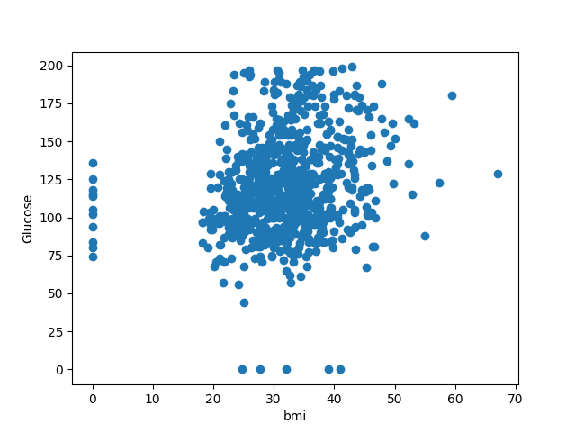

plt.hist(df['preg'])
plt.show()
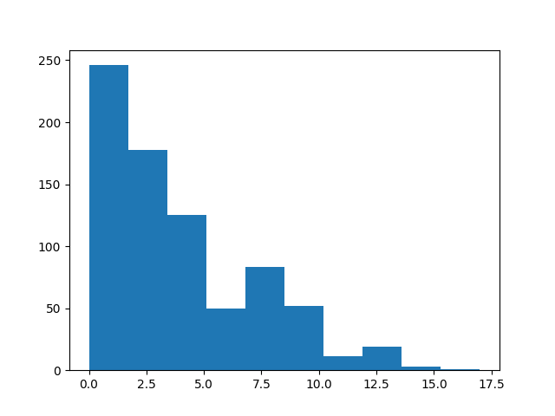

plt.boxplot(df)
plt.show()
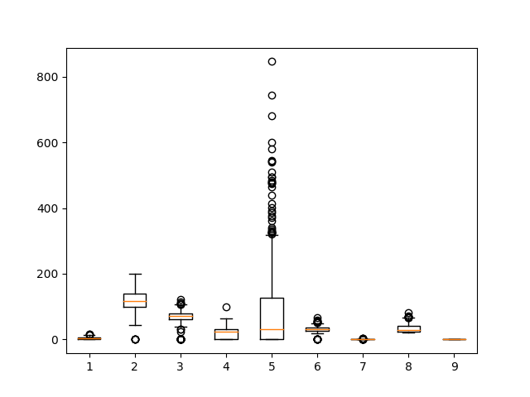

W = pd.read_csv('Lab2-files/wine_for_Week2.xls',header=None)
print(W.head())

0 1 2 3 4 5 6 7 8 9 10 11 12 13
0 1 14.23 1.71 2.43 15.6 127 2.80 3.06 0.28 2.29 5.64 1.04 3.92 1065
1 1 13.20 1.78 2.14 11.2 100 2.65 2.76 0.26 1.28 4.38 1.05 3.40 1050
2 1 13.16 2.36 2.67 18.6 101 2.80 3.24 0.30 2.81 5.68 1.03 3.17 1185
3 1 14.37 1.95 2.50 16.8 113 3.85 3.49 0.24 2.18 7.80 0.86 3.45 1480
4 1 13.24 2.59 2.87 21.0 118 2.80 2.69 0.39 1.82 4.32 1.04 2.93 735

G=pd.read_excel('Lab2-files/German_Credit_for_Week2.xlsx',sheet_name='Sheet1')
print(G.head())

Creditability CreditAmount DurationOfCreditInMonths
0 1 1049 18
1 1 2799 9
2 1 841 12
3 1 2122 12
4 1 2171 12

D = np.loadtxt('Lab2-files/xyz.txt',delimiter=',')
print(D[:5,:])

[[1000. 200. 500.]
[ 500. 45. 56.]
[2000. 2200. 4500.]
[5070. 465. 556.]
[8000. 8200. 5800.]]

B = pd.read_html('Lab2-files/Test runs-1.html')
print(B)

Too Big Output

H = pd.read_table('Lab2-files/HR.txt')
print(H.head())

Individual Attrition ... YearsSinceLastPromotion YearsWithCurrManager
0 Ind1 Yes ... 0 5
1 Ind2 No ... 1 7
2 Ind3 Yes ... 0 0
3 Ind4 No ... 3 0
4 Ind5 No ... 2 2

f = H['Department'].value_counts()
print(f)

Department
2 961
1 446
3 63

f.plot(kind='bar')
plt.show()
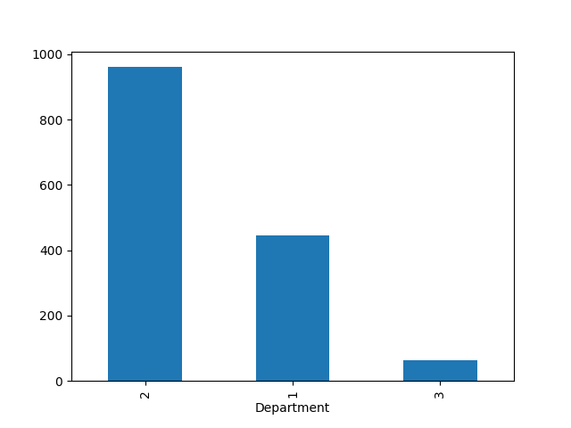

f.plot(kind='pie')
plt.show()

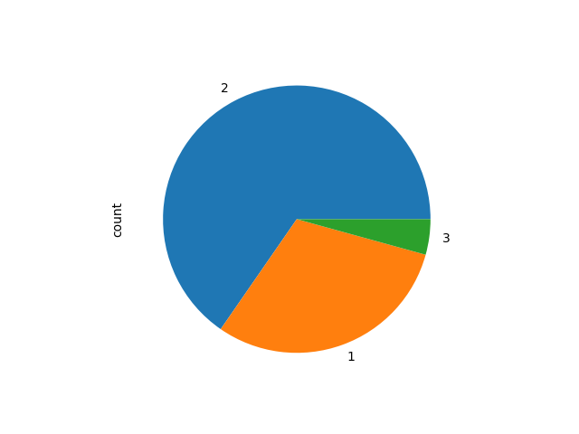

pip3 install lxml html5lib openpyxl

